

A peer to peer network is a decentralized network type where computers connect to each other rather than to a centralized server.



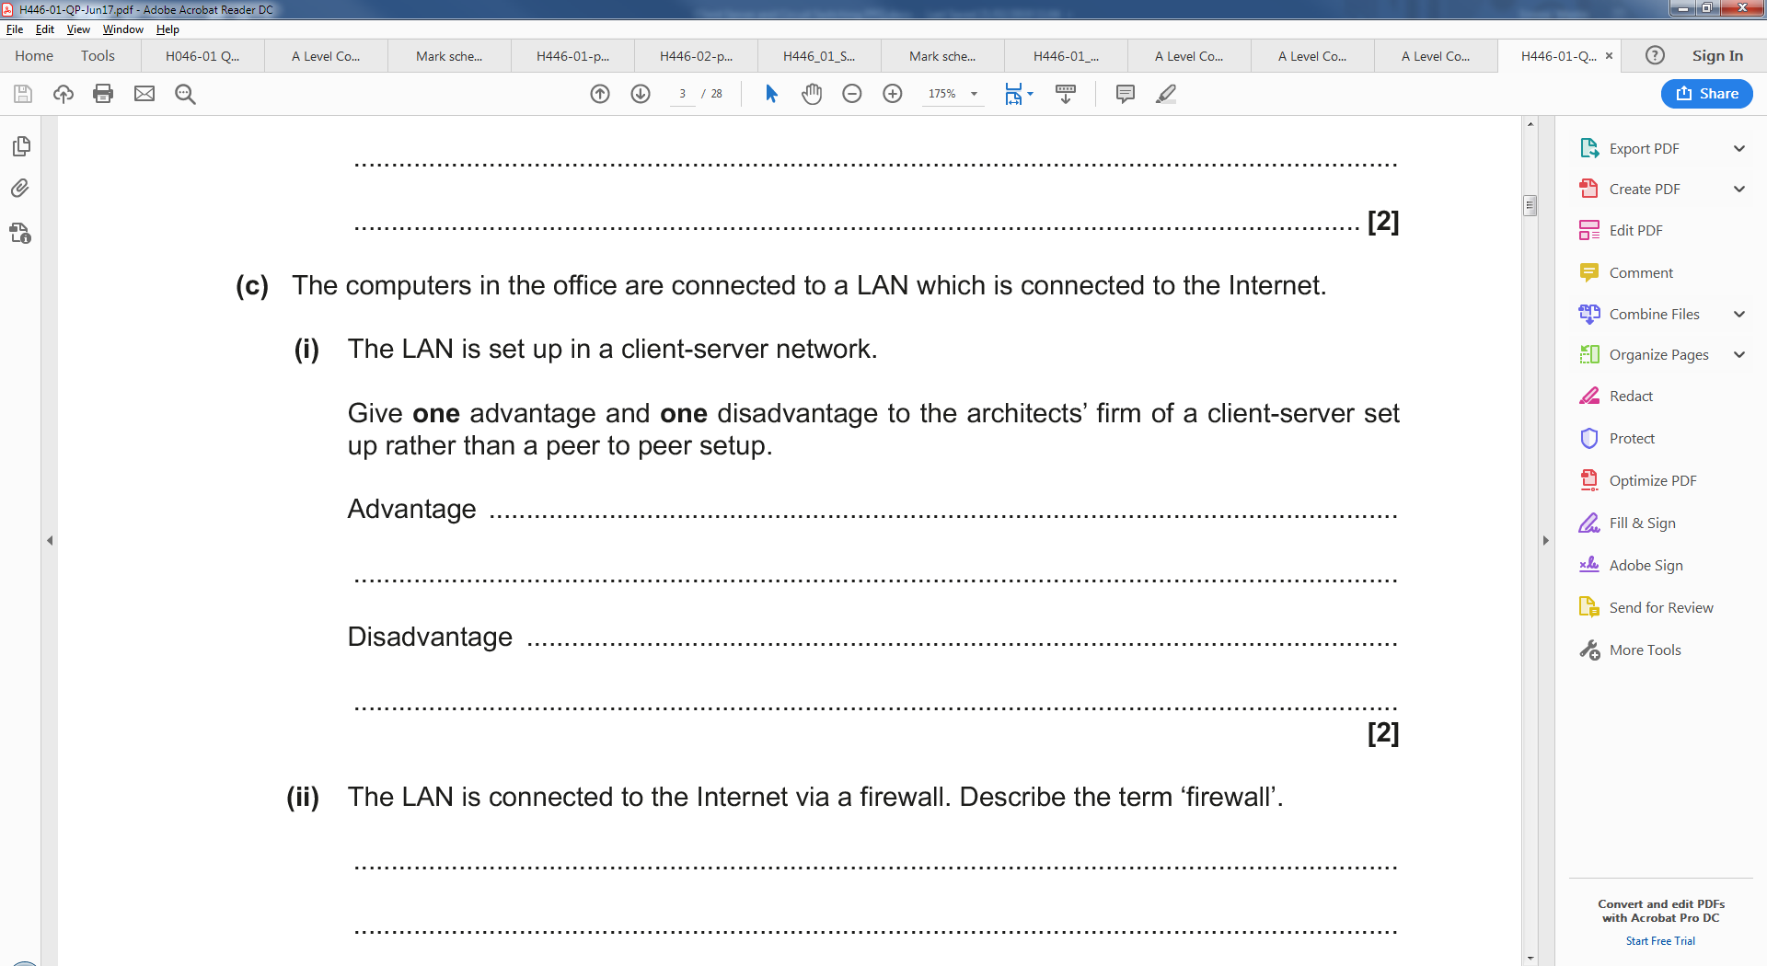

An advantage of the client server network type is that all files are always available to the network as servers run continually. It also means that backups can be made centrally. Collaborative working

A disadvantage is that servers cost large amounts of money. Large network trafic



Circuit switching generates the optimum route before data is sent. This means that all the data takes the sme route to the destination. As a result of this packets always take the



